**Project 2 (SEO/SEM)**

**SEARCH ENGINE OPTIMIZATION:**

**TRAVEL AGENCY (INTERNATIONAL TOUR OPERATOR)**

1. **Perform keyword research using keyword planner**

| **Keyword** | **Avg. monthly searches** | **Competition** | **Top of page bid (low range)** | **Top of page bid (high range)** |
| --- | --- | --- | --- | --- |
| tour packages agency | 10 – 100 | Low | 10.86 | 41.97 |
| international tour agency | 10 – 100 | Low | 7.16 | 56.45 |
| travel agency | 10K – 100K | Low | 7.34 | 30.92 |
| tour agent | 1K – 10K | Low | 6.81 | 25.22 |
| travel companies | 1K – 10K | Low | 8.38 | 34.27 |
| best travel agency | 1K – 10K | Low | 7.45 | 29.89 |
| travel tour companies | 1K – 10K | Low | 8.66 | 32.36 |
| luxury tour companies | 10 – 100 | Medium | - | - |
| global travel agency | 100 – 1K | Low | 8.3 | 38.44 |
| european tour companies | 10 – 100 | Medium | 20.44 | 78.28 |

1. **Create Meta Title and descriptions**

### **Luxury International Tours**

* **Meta Title**: Luxury International Tours | Tailored Travel Packages for Every Destination
* **Meta Description**: Explore the world with our customized luxury tours. From Europe to Asia, enjoy exclusive travel packages, all-inclusive resorts, and VIP experiences. Book your dream vacation today!

### **Affordable International Vacation Packages**

* **Meta Title**: Affordable International Vacation Packages | Explore the World on a Budget
* **Meta Description**: Discover budget-friendly international tours with all-inclusive options. Visit Europe, Asia, and more with top travel deals. Book your dream vacation at unbeatable prices now!

1. **Write a 600 word SEO friendly website content**

**Explore the World with Our Tailor-Made International Tours**

**Luxury International Tour’s** philosophy is that any journey has to be revelatory to the host. Seeking luxury international tours or cheaper vacations or adventurous activities – all and more are covered in our packages. With us, getting the most interesting vacation is just a matter of booking.

**Why Should You Book an International Tour with Us?**

We are an international tour operator that provides world class planned tours. Whether in the busy cities in Europe or more peaceful nature destinations in Asia, our clients can choose a perfect combination that fits their lifestyle. The reasons have made us one of the most desirable planners for international trips are as follows

**Customized Travel Packages**: Travelers differ and hence our tours differ as well. Be it relaxation at an all-inclusive resort or an adventurous solo backpacking trip, we provide fully tailored made itineraries to fit your destination.

**Experienced Local Guides**: On every trip, we deploy travel professionals that work in a team with local specialists for an authentic experience. Be it a tourist-centric trip or an offbeat journey, we will make it the most amazing trip of your life.

**Flexible Options**: Whether you are seeking a lavish escape, a fun-filled family vacation, or an action-packed experience, we have options to meet your travel aspirations. Choose from group tours, individual packages, or fully customized itineraries.

**Affordable Prices**: To travel across the globe, it is usually thought that one has to spend a great deal of money but with us, this is not the case at all. We offer cheap holiday packages for international destinations and practices which help you visit great places without quality being affected.

**Our Top International Tour Destinations**

Join our international tours and visit some of the most coveted places in the world. If you want to relax on a beach, visit archeological sites, or go on an adventure trip – we have it all for you.

1. **Europe – A Journey Through History**

Our travel agency provides enjoyment with affordable international tours country specific Europe trips. Paris, Rome, London and other well-known capitals which are landmarks of the history of civilization or even the arrogant edge of civilization such as the Croatian seaside or the Swiss alps. Our European tours barely meet only the expectations of art enthusiasts or history hunters but covers all other.

1. **Asia – A Land of Ancient Wonders**

Different countries have a distinct charm and one such continent is Asia. Leaving the domestic domain is not easy, and everyone has a country – however for an individual like me packages or even guiding systems to places like Thailand, Japan, India and China promise a fascinating experience. Also the magnificent structures of centuries old temples or street bazaars of China may intrigue you.

1. **Adventure Travel Tours – For the Adventurists**

If gory moments are your craving, our adventure travel tours must be giving you relief. Take an African safari, hiking in the Himalayas, or scuba diving the great barrier reef in Australia. Our adventure packages are meant for adventurers in search of remarkable and once in a lifetime adventure opportunities from all corners of the world.

1. **Visa-Free Travel Destinations**

Do you want a stress free vacation whereby you will not need to apply for a visa? Try our visa free travel holidays range on offer that are excellent for such spur of the moment trips. From sunshine and sand on Caribbean islands to cultural retreats in South East Asia, travel where no visa is required and the trip is enjoyable and convenient.

**Reasonably Priced International Holiday Deals**

We know how important planning for a budget is when you're preparing for an overseas trip. That’s why we have come up with many cheap international holiday deals. Whether you are after a romantic hideaway, a family holiday or a holiday with friends, we shall search for the most affordable flights, accommodation, and activities for you.

Our low-priced packages do not skimp on any quality. You will have the best of the best places to stay with entertainment, expeditions, and concierge at the most courteous rates. Book our fantastic offers and travel to more destinations and pay less.

**Group Travel Packages – Travel Together, Stay Together**

It isn’t very easy to organize and plan out a trip for a group of people but we simplify it by providing group travel packages. Be it a family gathering, a business retreat or a getaway with friends; we will create the best itinerary for the group. Take advantage of these great benefits, private tours, group discount rates and customized programmes prepared with your group in mind.

**Grab Your International Honeymoon Tour Package Now**

Excited to start your next holiday? Want a hassle free international tour? Turn to **Luxury International Tours**. If you are looking for a trip to Europe, Asia, or even somewhere in the other parts of the world and want it packaged, look no further. We have it all for you.

Contact us today so that we can help you organize an interesting and enjoyable international tour which you will remember for many years!

**4. Write a 1000 word blog to promote the service**



**Discover the World with Tailored International Tours: Unforgettable Travel Experiences for Every Type of Explorer**

In today's fast-paced world, traveling is one of the most rewarding ways to disconnect from daily routines, explore new cultures, and create lasting memories. But planning the perfect international vacation can be daunting, especially with the endless choices of destinations, accommodations, and activities. That’s where a reliable international tour operator like **Luxury International Tours** comes in, offering expert guidance, personalized itineraries, and hassle-free bookings to ensure that your next global adventure is truly unforgettable.

Whether you’re dreaming of a luxury getaway to Europe, an affordable trip to Southeast Asia, or a thrilling adventure in Africa, we have the perfect travel package for you. Let’s explore how our tailored international tours can transform your vacation into the experience of a lifetime.

### **Why Choose a Customized International Tour?**

When planning a vacation, the first step is often deciding where to go and what to do. But with so many countries, cultures, and attractions to choose from, the decision-making process can quickly become overwhelming. This is where a customized tour can make all the difference.

At **Luxury International Tours**, we specialize in designing tailor-made international tours that are built around your unique travel preferences, interests, and budget. Here are just a few reasons why customized tours are the best way to explore the world:

#### **1. Personalized Itineraries**

Rather than choosing from pre-packaged tours, a customized international tour is designed specifically for you. Whether you want to focus on historical landmarks, culinary experiences, adventure activities, or relaxation, we will create an itinerary that perfectly matches your travel goals. Our tours offer the flexibility to explore at your own pace, ensuring that every moment of your vacation is enjoyable.

#### **2. Hassle-Free Planning**

Planning an international vacation involves countless details, from securing flights and accommodations to organizing transportation and excursions. With our expert travel team, all of this is handled for you. We take care of the logistics so that you can focus on enjoying your trip. Whether it's obtaining necessary visas, arranging private guides, or securing reservations at top restaurants, we ensure that every aspect of your trip is seamless and stress-free.

#### **3. Authentic Local Experiences**

As experienced tour operators, we have long-standing partnerships with local guides, hotels, and excursion providers in every destination. This allows us to offer authentic, off-the-beaten-path experiences that you won’t find in standard travel guides. Whether it’s a private wine tasting in Tuscany, a hidden temple tour in Thailand, or a visit to a local artisan market in Morocco, you’ll have the opportunity to immerse yourself in the true essence of each destination.

### **Top International Destinations You Should Visit**

With so many incredible destinations around the globe, choosing where to travel next can be a challenge. Here are some of the top regions we specialize in that cater to a wide variety of travel interests:

#### **1. Europe – The Ultimate Luxury Escape**

For travelers seeking a mix of culture, history, and elegance, Europe is an unrivaled destination. From the romantic streets of Paris to the ancient ruins of Rome, Europe offers something for every kind of traveler. Our luxury international tours to Europe include stays at boutique hotels, private guided tours of world-famous landmarks, and opportunities to indulge in the region’s finest cuisine and wine. Highlights of our European tours include:

* **Paris, France:** Explore iconic sights such as the Eiffel Tower, Louvre Museum, and Montmartre while indulging in world-class dining and shopping.
* **Tuscany, Italy:** Experience the beauty of the Italian countryside, with wine-tasting tours, visits to Renaissance cities like Florence, and serene countryside stays.
* **Santorini, Greece:** Unwind on one of the world’s most picturesque islands, known for its stunning sunsets, whitewashed buildings, and crystal-clear waters.

#### **2. Asia – Explore a Continent of Contrasts**

Asia is an incredibly diverse continent that offers a rich blend of ancient traditions, modern innovations, and natural wonders. Whether you’re looking to trek through the Himalayas, explore bustling city markets, or relax on a tropical beach, our Asia travel packages have you covered. Some of our top Asian destinations include:

* **Thailand:** From the vibrant streets of Bangkok to the serene beaches of Phuket, Thailand is a must-visit for those who crave adventure, culture, and relaxation.
* **Japan:** Discover the unique blend of ancient and modern in Japan. Visit Kyoto’s temples, explore Tokyo’s skyscrapers, and relax in traditional ryokan inns.
* **India:** From the majestic Taj Mahal to the vibrant colors of Rajasthan, India offers an unforgettable travel experience filled with culture, spirituality, and history.

#### **3. Adventure Travel – For the Thrill Seekers**

Are you the type of traveler who craves adrenaline-pumping experiences? Our adventure travel tours are designed for thrill-seekers who want to go beyond traditional sightseeing. From safaris in Africa to trekking expeditions in the Andes, our adventure packages promise unforgettable experiences in the world’s most exhilarating destinations. Highlights include:

* **African Safari:** Embark on a thrilling safari to spot the “Big Five” in Kenya’s Maasai Mara or Tanzania’s Serengeti.
* **Peru’s Inca Trail:** Trek through the Andes Mountains to the ancient city of Machu Picchu, one of the world’s most iconic archaeological sites.
* **Australia’s Great Barrier Reef:** Dive into the waters of the world’s largest coral reef system and discover a stunning underwater world.

#### **4. Visa-Free Travel Destinations – Stress-Free Global Exploration**

If you’re looking for a spontaneous getaway without the hassle of visa applications, we offer a wide range of visa-free travel destinations. From tropical islands to cultural havens, these destinations offer the perfect opportunity to pack your bags and go. Some of our top visa-free travel locations include:

* **Bali, Indonesia:** Relax on Bali’s pristine beaches, explore ancient temples, and immerse yourself in the island’s vibrant culture.
* **Maldives:** Experience ultimate luxury in the Maldives, where you can stay in overwater bungalows and snorkel in crystal-clear lagoons.
* **Singapore:** This modern city-state offers a unique mix of futuristic architecture, diverse culinary scenes, and lush gardens.

### **Affordable International Vacation Packages – Travel the World Without Breaking the Bank**

At **Luxury International Tours**, we believe that world-class travel experiences shouldn’t come with a hefty price tag. That’s why we offer a wide selection of affordable international vacation packages designed to give you the best value for your money. Whether you’re traveling as a family, a couple, or a solo adventurer, our budget-friendly packages allow you to explore top global destinations without compromising on quality.

You’ll enjoy comfortable accommodations, exciting activities, and top-notch service, all at an affordable price. Our team works tirelessly to find the best deals on flights, hotels, and excursions, so you can focus on creating unforgettable memories.

### **Book Your Next International Tour Today**

Ready to start your next global adventure? Whether you’re planning a luxury escape, an adventure-filled expedition, or a budget-friendly vacation, **Luxury International Tours** is here to make your dream trip a reality. With our customized international tours, expert travel guidance, and unbeatable service, you’ll have everything you need for an unforgettable experience.

Contact us today to book your next international tour and discover the world in a whole new way!

**SOCIAL MEDIA MARKETING PROJECT:**

**1. Competitor Analysis**

#### **Company 1: SOTC Travel**

#### **Company 2: Thomas Cook India**

### **1. Overview & Target Audience**

* **SOTC Travel**: A well-established Indian tour operator offering a mix of customized luxury tours and budget travel packages. Their target audience includes middle-income families, honeymooners, and corporate travelers.
* **Thomas Cook India**: A leading tour operator that caters to both luxury and budget travelers, offering a wide range of travel services including holiday packages, corporate travel management, and foreign exchange.

**Target Audience Summary**:

* **SOTC Travel** focuses on providing a variety of travel experiences, including group tours, family vacations, and budget tours.
* **Thomas Cook India** serves a similar audience but places a stronger emphasis on corporate travel, foreign exchange services, and travel insurance.

### **2. Service Offerings**

* **SOTC Travel**:
  + Customized and group international tours.
  + All-inclusive family vacation packages.
  + Cruise vacations and honeymoon packages.
  + Visa assistance, travel insurance, and foreign exchange.
* **Thomas Cook India**:
  + International tour packages (luxury and budget).
  + Corporate travel solutions and business travel management.
  + Foreign exchange, travel insurance, and visa services.
  + Special tours for adventure, wellness, and spiritual travel.

**Key Differences**:

* **SOTC Travel** offers a wide range of travel packages, focusing more on family and group vacations.
* **Thomas Cook India** has a more comprehensive offering, including corporate services and more niche travel options like wellness and spiritual tourism.

### **3. Price Range**

* **SOTC Travel**:
  + Average price per international package: ₹50,000 – ₹2,50,000 per person.
  + Offers group discounts and budget-friendly packages, but also caters to mid-range and luxury travelers.
* **Thomas Cook India**:
  + Average price per international package: ₹45,000 – ₹3,00,000 per person.
  + Offers more high-end travel options in addition to budget packages, and provides various add-ons like corporate travel perks and forex services.

**Price Competitiveness**:

* **SOTC Travel** provides mid-range pricing for family and group vacations.
* **Thomas Cook India** has a slightly wider price range, with more options for both premium and budget travelers.

### **4. Destination Specialization**

* **SOTC Travel**:
  + Specializes in destinations across Europe, Asia, and the Americas.
  + Popular for their international family vacation packages, Europe tours, and group travel to visa-free countries.
* **Thomas Cook India**:
  + Strong focus on Europe, Southeast Asia, and the Middle East.
  + Specializes in corporate travel to international destinations and offers exclusive wellness retreats in Asia and Europe.

**Specialization Insights**:

* **SOTC Travel** is known for their family-friendly vacation packages and visa-free travel destinations.
* **Thomas Cook India** differentiates with specialized offerings like wellness retreats and corporate travel management.

### **5. Website & Online Experience**

* **SOTC Travel**:
  + User-friendly website with a focus on popular tours and promotions.
  + Features easy booking options, trip details, and testimonials from travelers.
  + Lacks extensive personalization options on the website.
* **Thomas Cook India**:
  + A more polished and professional website with detailed descriptions of destinations and services.
  + Includes travel calculators, foreign exchange services, and corporate travel tools.
  + Offers a blog and destination guides for both luxury and budget travelers.

**User Experience**:

* **SOTC Travel** provides a simple and functional website that highlights travel deals and packages.
* **Thomas Cook India** offers a more robust digital experience with additional tools for corporate and luxury travelers.

### **6. SEO & Digital Marketing Strategy**

* **SOTC Travel**:
  + Strong focus on SEO with keywords such as "international family tours," "affordable travel packages," and "group vacations from India."
  + Active on social media platforms, promoting travel deals and showcasing user experiences.
  + Engages in email marketing with personalized offers.
* **Thomas Cook India**:
  + Targets a mix of budget and premium travel keywords like "luxury international tours," "corporate travel solutions," and "affordable Europe tours."
  + Invests in content marketing through travel blogs, guides, and destination highlights.
  + Leverages social media and paid advertisements to promote exclusive deals and services.

**Digital Marketing Analysis**:

* **SOTC Travel** focuses on deal-based marketing to attract middle-income families and groups.
* **Thomas Cook India** invests heavily in content marketing and corporate travel promotions to appeal to both luxury and business travelers.

### **7. Customer Reviews & Reputation**

* **SOTC Travel**:
  + Customers praise the company for affordable packages, smooth logistics, and good customer service.
  + Some complaints about limited customization options and issues with visa processing.
* **Thomas Cook India**:
  + Reviews highlight their comprehensive service offerings, including foreign exchange and visa support.
  + Some negative feedback regarding higher prices for premium services.

**Reputation Summary**:

* **SOTC Travel** is known for delivering value in family and group vacations but could improve in personalization.
* **Thomas Cook India** is well-regarded for their wide range of services, especially for corporate and luxury clients, though some find the pricing on the higher side.

### **8. Strengths & Weaknesses**

| **Aspect** | **SOTC Travel** | **Thomas Cook India** |
| --- | --- | --- |
| **Strengths** | - Affordable family vacation packages | - Comprehensive travel services |
|  | - Group travel discounts | - Strong corporate travel solutions |
|  | - Easy booking and support | - Luxury travel options and wellness retreats |
| **Weaknesses** | - Limited customization options | - Higher prices for premium services |
|  | - Some logistical challenges in visa handling | - Focus on corporate travel may alienate budget travelers |

### 

### **9. Opportunities for Our Company**

Based on this analysis, here’s how your international tour operator business can differentiate:

* **Balanced Packages**: Position your brand between the two competitors by offering a combination of affordable family vacations and mid-range luxury options.
* **Enhanced Online Experience**: Invest in a user-friendly website with customization tools and blogs to help travelers plan their trips.
* **Focus on Unique Destinations**: Emphasize off-the-beaten-path destinations and adventure travel to appeal to both luxury and budget travelers.
* **Competitive Pricing**: Offer competitive pricing and add-ons like visa support and flexible payment options, while differentiating with personalized tours.

**2. Target Audience for Paid Facebook and Instagram Ads**

#### **1. Demographic Segmentation**

Understanding your target audience’s demographic details is essential for creating tailored ads that resonate with them.

* **Age**:
  + **Primary Age Group**: 25-45 years  
    This segment includes young professionals, families, and married couples who are likely to travel internationally for leisure, honeymoons, or family vacations.
  + **Secondary Age Group**: 46-60 years  
    These are individuals planning luxury vacations, retirees looking to travel the world, and people seeking wellness or spiritual retreats abroad.
* **Gender**:
  + **Men and Women**Both genders are equally engaged in travel decisions, with women often leading the planning for family vacations or romantic getaways.
* **Income Level**:
  + **Middle to High Income** (₹10,00,000 – ₹40,00,000 annually)  
    Target professionals and families with disposable income to afford international vacations, as well as high-income earners who seek luxury travel experiences.
* **Marital Status**:
  + **Married and Newly Married Couples**This group often looks for honeymoon packages, romantic getaways, or family vacations, especially during holiday seasons.
* **Occupation**:
  + **Corporate Employees, Business Owners, and Entrepreneurs**These are individuals who have stable income levels and can afford regular vacations abroad.

#### **2. Geographic Segmentation**

Since you are targeting an Indian audience, we can refine geographic targeting to major cities and regions with the highest likelihood of booking international tours.

* **Cities to Target**:
  + **Tier 1 Cities**: Mumbai, Delhi, Bengaluru, Chennai, Hyderabad, Pune, Kolkata  
    Residents of these cities are more likely to have the financial capacity and interest in international vacations.
  + **Tier 2 Cities**: Jaipur, Ahmedabad, Coimbatore, Chandigarh, Lucknow, Indore  
    People from Tier 2 cities are increasingly showing interest in international travel, particularly affordable or family-oriented packages.

#### **3. Interest-Based Segmentation**

On Facebook and Instagram, you can target users based on their interests and behaviors. This will help you reach individuals who are actively interested in travel.

* **Travel-Related Interests**:
  + International Travel
  + Luxury Travel
  + Adventure Travel
  + Honeymoon and Romantic Getaways
  + Group Travel
  + Beach Holidays
  + Cultural Tours
* **Specific Destinations**:  
  Target people who show interest in specific destinations you offer, such as Europe, Southeast Asia, the Maldives, or the Middle East.
* **Competitor Interests**:
  + Users who engage with or have shown interest in brands like SOTC, Thomas Cook, MakeMyTrip, and other travel aggregators.
* **Holiday Preferences**:
  + Users who have recently engaged with content about holiday planning, visa information, or flight bookings.
* **Lifestyle & Interests**:
  + **Adventure Seekers**: People interested in activities like hiking, trekking, scuba diving, etc.
  + **Luxury Lifestyle**: Individuals interested in luxury resorts, fine dining, and exclusive experiences.
  + **Family & Parenting**: Families planning vacations during school holidays.
  + **Young Couples**: Engaged or recently married couples looking for honeymoon destinations.

#### **4. Behavioral Segmentation**

Behavioral data provides insights into users’ online behavior, purchase intent, and past activities.

* **Frequent Travelers**:  
  Target individuals who have recently returned from or shown an interest in international destinations or luxury hotels.
* **Upcoming Trips**:  
  Facebook and Instagram offer behavioral targeting based on users who are planning an upcoming trip or have used travel-related apps (flight search, hotel booking) recently.
* **Luxury Shoppers**:  
  Users who frequently purchase high-end products or services are likely to be interested in luxury vacation packages.
* **Expats or NRI Families**:  
  Indian families living abroad or frequently traveling to visit family back in India, who may book vacations while visiting.

#### **5. Custom Audiences & Lookalike Audiences**

Use your existing customer base to create custom and lookalike audiences on Facebook and Instagram.

* **Custom Audiences**:
  + Upload your existing customer database (if you have one) to target individuals who have already purchased or shown interest in your services.
  + Use website traffic (via Facebook Pixel) to retarget individuals who have visited your website but did not complete a booking.
* **Lookalike Audiences**:
  + Create a lookalike audience from your custom audience to target new users with similar characteristics and behaviors to your current customers.
  + Refine the lookalike audience based on specific locations (India) and interests in travel.

#### **6. Seasonal Targeting**

Travel companies often see increased demand during specific seasons or holiday periods.

* **Holiday Travel**:  
  Focus on peak travel seasons like summer vacations (April-June), winter holidays (November-December), and long weekends.  
  Target users planning for holiday getaways or family vacations during these periods.
* **Honeymoon Season**:  
  Honeymoon packages can be heavily promoted during wedding seasons (October-March in India).
* **Festivals**:  
  Target individuals looking to plan trips around major festivals like Diwali, New Year, or during regional holiday periods.

**3. Create an Ad copy design**

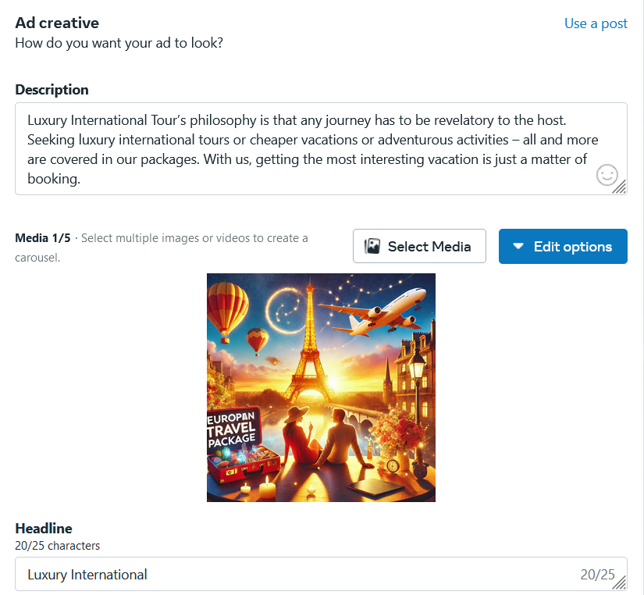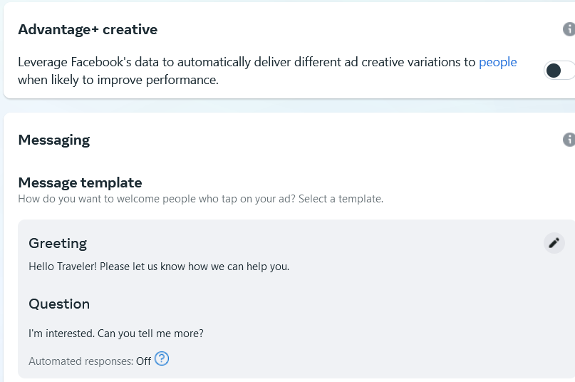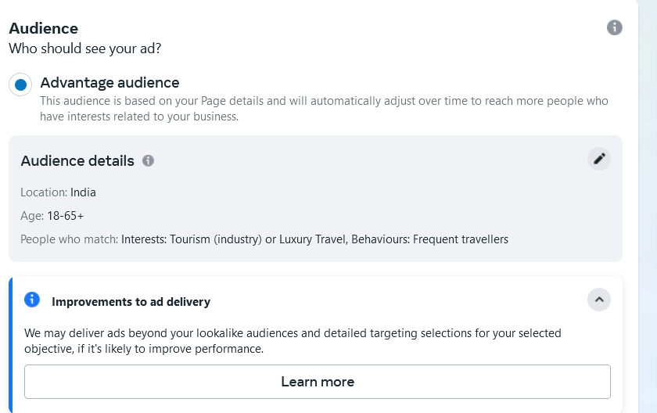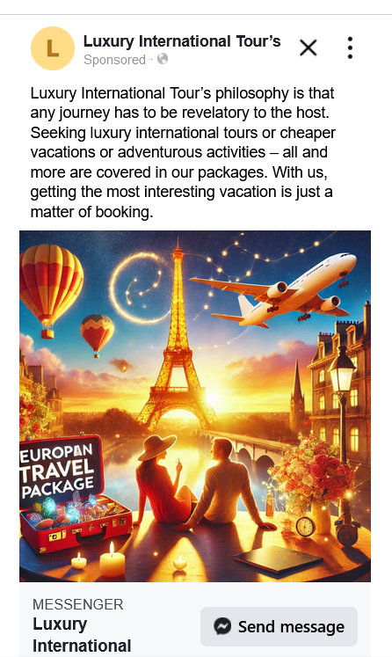

**4. Create a Facebook/ Instagram Lead Gen Campaign**

